**DAILY ONLINE ACTIVITIES SUMMARY**

|  |  |  |  |  |  |  |  |  |
| --- | --- | --- | --- | --- | --- | --- | --- | --- |
| **Date:** | **18-05-2020** | | | | | **Name:** | **AKASH S** | |
| **Sem & Sec** | **4th&A** | | | | | **USN:** | **4AL18CS004** | |
| **Online Test Summary** | | | | | | | | |
| **Subject** | | **COMPLEX ANALYSIS,PROBABILITY AND STASTICAL METHOD** | | | | | | |
| **Max. Marks** | | **30** | | **Score** | | | **_** | |
| **Certification Course Summary** | | | | | | | | |
| **Course** | **PYTHON FOR MACHINE LEARNING** | | | | | | | |
| **Certificate Provider** | | | **GREATLEARNING** | | **Duration** | | | **2.5HOURS** |
| **Coding Challenges** | | | | | | | | |
| **Problem Statement1:To check the given strings are anagram or not** | | | | | | | | |
| **Status: executed** | | | | | | | | |
| **Uploaded the report in Github** | | | | | **YES** | | | |
| **If yes Repository name** | | | | | **1.https://github.com/akashacharya786/lockdown-coding/blob/master/anagram.c** | | | |
| **Uploaded the report in slack** | | | | | **YES** | | | |

Online Test summary:18MAT21 test was scheduled from 9:30 am to 10 am And the syllabus IA test was 4TH module there were 30 questions and the time limit for the test is 30minutes the question were mcq type .The test scores are not yet received.

Online Certification Course Summary: I have opted my Online Certification Course In great learning the course which opted is PYTHON FOR MACHINE LEARNING. This course contains assessments and practice assessments the faculty is Dan Mitchell-Assistant professor .Today I have gone through the python introduction and I came to know the is easy to learn. We can also use python when out data analysis task needs to be incorporated into a production data base. B being a full-fledged programming language, it is a great tool to implement algorithms for production use.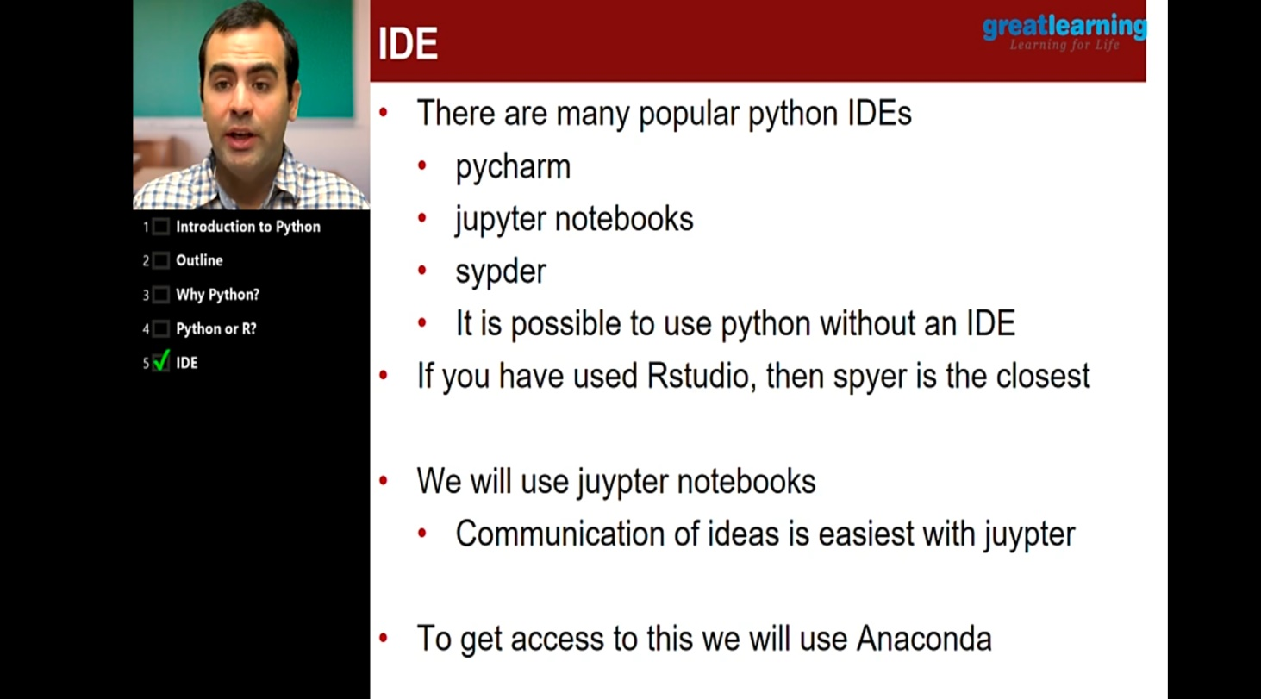

In this video I came to know what exactly is python programming language and difference between Python and R. I also known that Python is an open source and there are tons of package available and there are many popular python IDE’s like pycharm,jupyter note book and syper etc.In the next coming session I am going to know about Installation of jupyter notebook and Anaconda.

**Online Coding Summary: Today I had received two programs from prof.Venkatesh CSE Dept. I executed 1 program that is to check the given strings are anagram or not. I have written the program and uploaded it to my Github repository.**

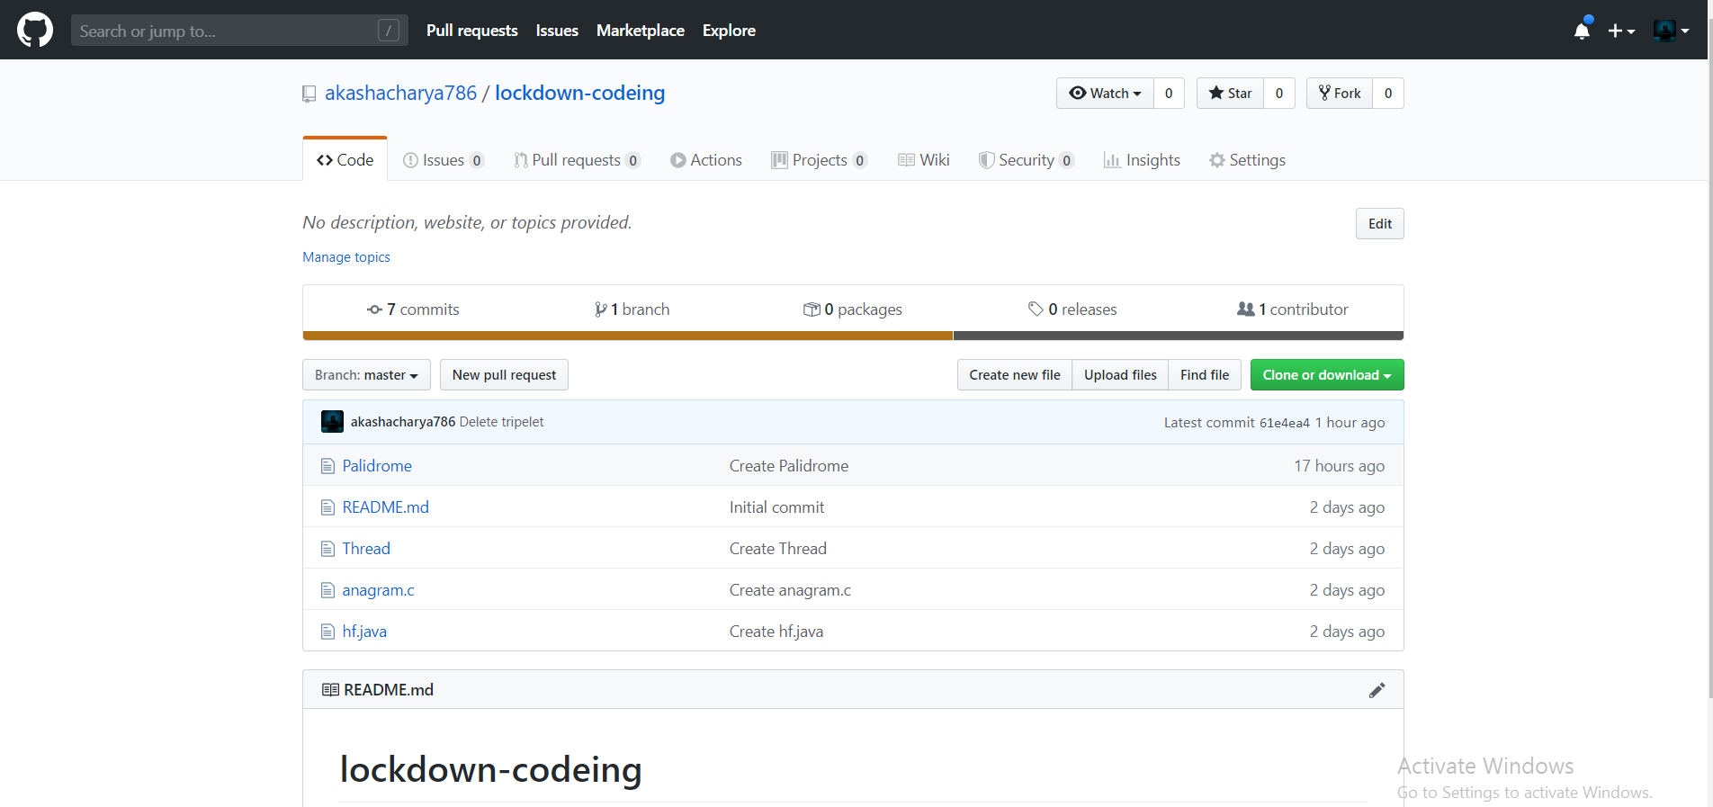

**This is my repository snap shot were I have uploaded both the programs.**